Final Project Design Phase
Computer Science - Week 11
Oct 3, 2026 - Version 0.0.4

For complete instructions and project ideas, refer to the assignment in Canvas. Specifically, review the final project requirements before you continue below. If you have not reviewed the project requirements in Canvas (you might have to go to the modules view and check the current or past week's content), you will not be able to properly complete the parts below. In addition, it may be helpful to review the information on this Drafter documentation page.

0) Project Planning and Preparation
Successful programmers spend time planning before they begin coding. After reviewing the project requirements, answer the following questions to help guide your design and development process.
- What concepts from class or previous assignments might help you complete this project? Which programming concepts (loops, conditionals, lists, classes, etc.) do you expect to use? What programming skills do you want to improve while completing this project?
Some concepts I will be using to create my program are functions, loops, if statements, list, and dataclasses. I want to use list to organize my program and if statements to implement the due date aspect of my program.

- Which parts of the project do you expect to be the easiest for you? The hardest? Why?
The easiest part of my program will be creating the pages and allowing the user to add the assignments into the program. The hardest part will be organizing the assignments and making sure they use the right outputs based on the due dates.

- Even though you have not yet designed the final project, estimate which tasks will likely require the most time and effort? Which features or components should be implemented first?
The most time consuming aspect of this project will be creating the routes and making sure the assignments are in an organized fashion. My first step in creating this project will be the pages and state. Then I will work on the assignment inputs and outputs.

- What distractions might interfere with your work and how will you minimize them? What resources will you need available while working? What questions, if any, do you still have about the assignment requirements?
Like every other student making a program, other work could possibly distract more or take up time reserved for this project. Also being part of a club sport could take up time, but since school is #1 priority I will choose doing work and getting my work done over a club sport.

1) Site Diagram
Create a mock-up of your planned website. We suggest you make the mockup on paper, although you can also use software like PowerPoint or Slides to make a mockup. There is other design software that could also be used, but we strongly encourage you to keep it simple. Do not spend more than 15-30 minutes detailing the mock-up. Your goal should be to make a very quick and dirty diagram, to show that you have some kind of idea.

We recommend drawing each page as a rectangle, and laying out the text, buttons, and other components inside. Then, use arrows to indicate links between pages. Label each page the way you will name each function, and then put labels on the arrows to indicate what the button links. Also write down any parameters that should come into the pages.

In addition to the pages and routes, write down what fields your `State` will have, both their names and types. Think clearly about what data will need to be persistent across the entire website.

Add photo(s) or screenshot(s) of your website mock-up and labeled diagram on the next page. 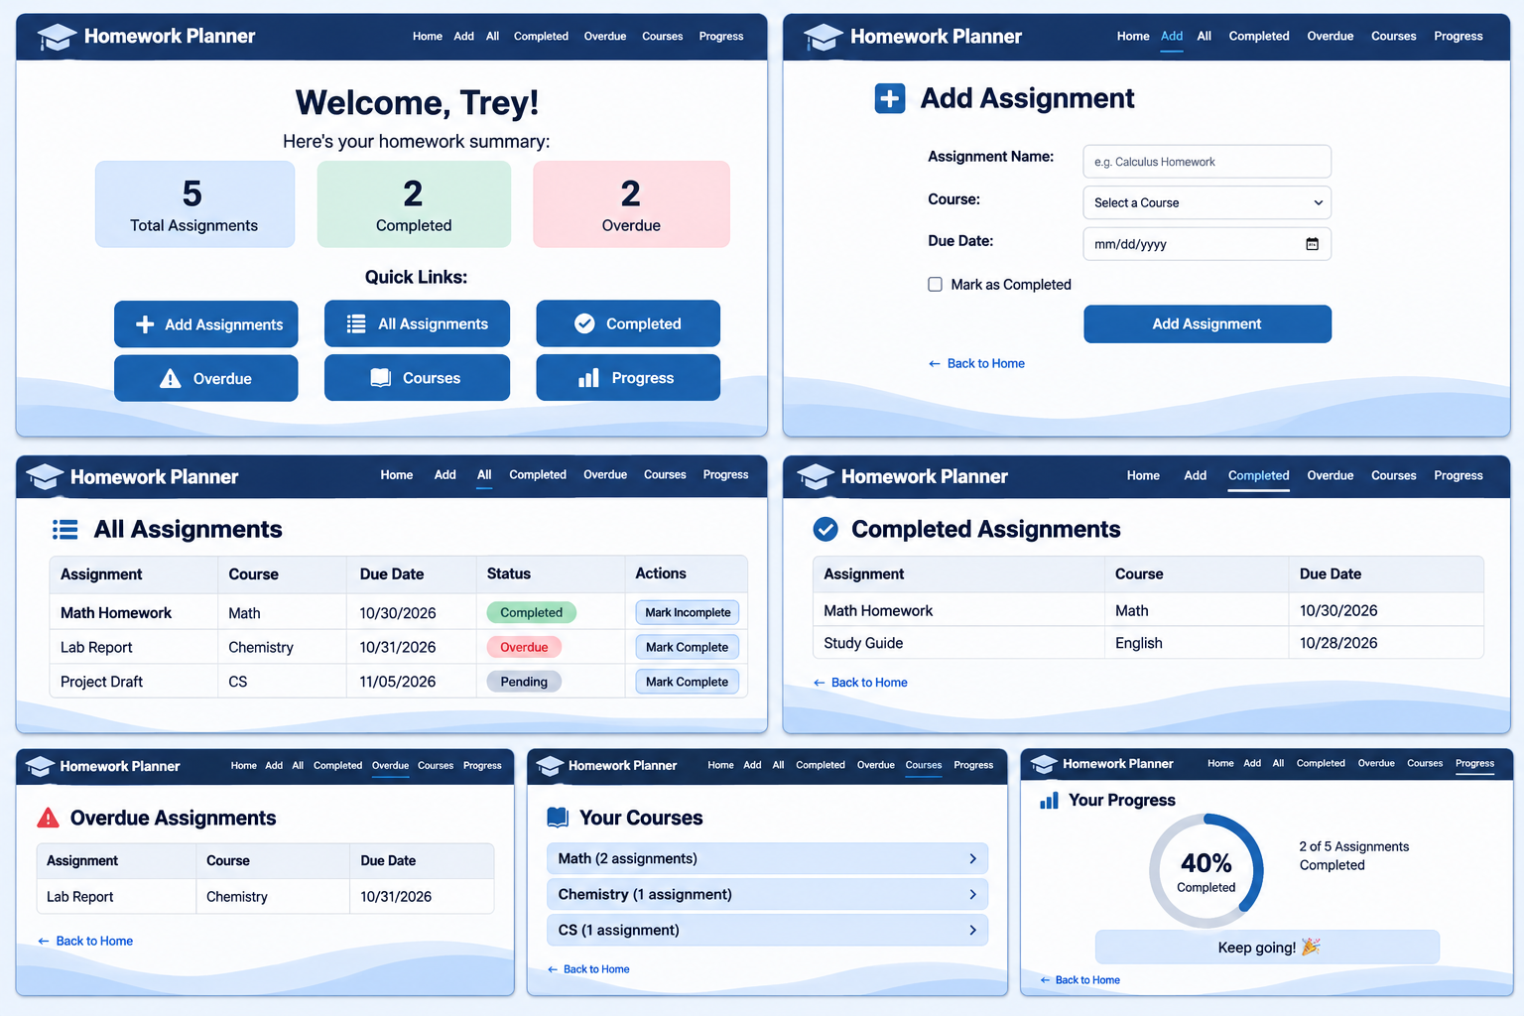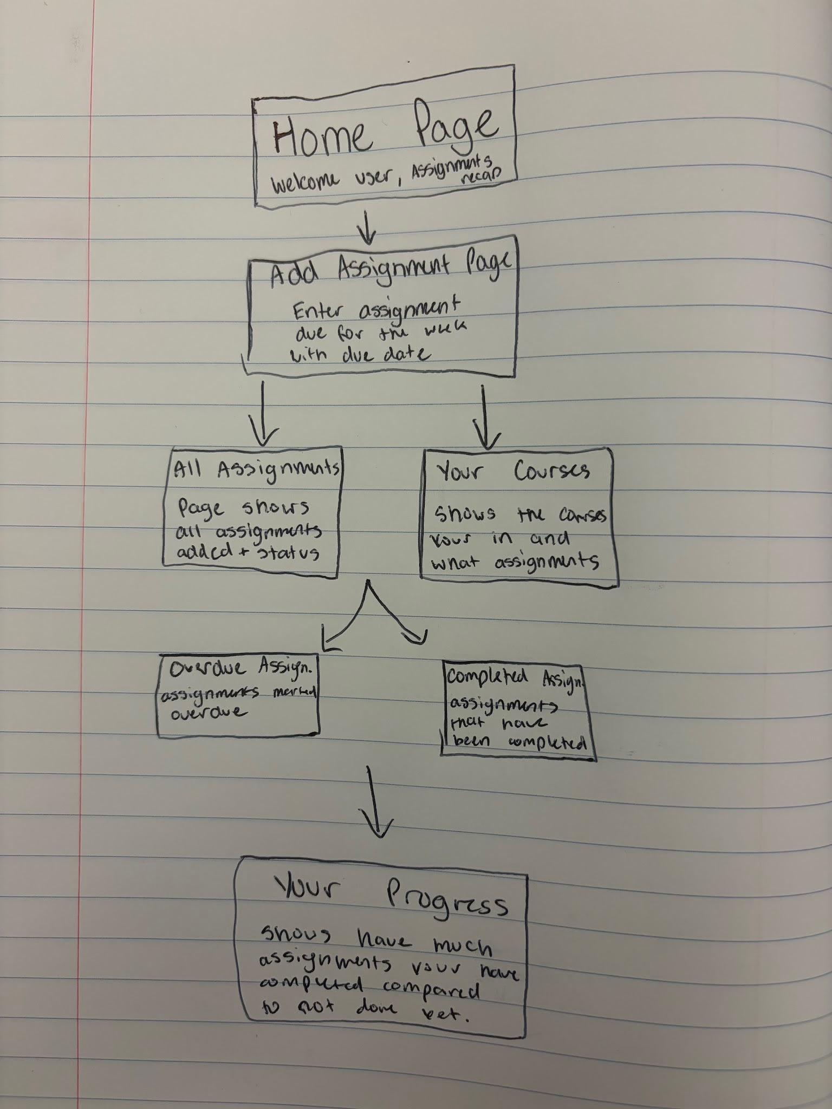

2) Implementing Requirements
This table should serve as a draft for how you will implement the requirements into your final project. You may change your ideas later on, but your final site must fulfill all the requirements.

Requirement | Implementation
Purpose/Functionality  A 1-2 sentence description of the purpose or functionality of your site | The purpose of my website is to help students organize their assignments and give a better look at when they have assignments due.
State Dataclass Attributes  Minimum of 4 attributes, one of which must be a list/dict of instances of your second dataclass.  Briefly describe each attribute, its type, and how it will be meaningfully modified throughout the site. | - assignments: list[Assignments] - store all assignments added by the user  - courses: list[str] - store the names of the courses added by the user  - student_name: str - the name of the user/student  - selected_course: str - stores the course selected by the user  - show_completed: bool - Tracks when an assignment is completed
Second Dataclass  Your second dataclass, including its attributes, their types, and how they will be meaningfully modified (if they are modified) | - Assignment_name: str - stores the name of the assignment  - Course: str - stores which class the assignment belongs to.  - Due_date: str - stores the due date of the assignment  - completed : bool - stores whether the assignment has been completed or not.
Routes (minimum 7)  The names of your route functions | - home_page()  - add_assignment()  - all_assignments()  - completed_assignments()  - overdue_assignments()  - courses_page()  - progress_page()
Pages (minimum 5)  A brief description of the pages in your site | - Home page- start up page that shows user’s assignments  - Add Assignment Page- page to enter new assignments  - All assignments page- Display of all assignments user displayed  - Competed Assignments Page- Shows the assignments completed.  - Overdue Assignments Page - Shows what assignments are overdue.  - Courses Page- organized the assignments by course  - Progress Page- shows how many assignments have been completed and how many are remaining.
User Input (minimum 3)  Description of user input components (TextBox, TextArea, CheckBox, or SelectBox) and their purposes  For more information on these input types, see Drafter Documentation. | - TextBox- Allows the user to enter assignment names  - SelectBox- Allows the user to select course for an assignment  - TextBox- Allows user to enter a due date.  - CheckBox- Box to mark once completed
If Statements (minimum 3)  Brief description of what will be evaluated in your if statements and how they will meaningfully change the logic of the site | - If statement for is an assignment is marked completed it will display on the right page.  - If statement for if an assignment is overdue if will show up on the Overdue Assignments Page.  - If an assignment is left empty the program will get rid of the assignment.
Loop (minimum 1)  This loop must iterate over the list/dict of dataclass instances in your State attribute.  Description of this loop and why it is meaningful to the site | The program will have a loop that will go through a list of assignments stored in a data class and check its status for completed, overdue or not done yet.

LLM Conversation
If you used an LLM in any part of this work, copy and paste every part of that conversation below. Otherwise, you may be given a zero for the assignment. Obviously, these words will not all be yours, and this is the exception to the requirement at the top of this assignment that all responses be in your own words. If you did not use an LLM to assist you in this assignment, simply say so below.
Me: What would be a good mock up of a website that helps a student add assignments, due dates and courses. That also organizes them by course and tells the user when an assignment is due.
LLM: Here is a mockup of what your Homework Planner website could look like!
The design includes all 7 pages:
Home
Add Assignment
All Assignments
Completed Assignments
Overdue Assignments
Courses
Progress
My recommendation: Use a navy blue and light blue color scheme. Keep the navigation bar at the top so users can easily move between pages.
You can use this as your visual guide when drawing the Site Diagram and building your actual website with Python and Drafter.
Me: What can “if statements” in python be used for in this program?
LLM:
- If an assignment is marked completed, the program will display it on the Completed Assignments page.
- If an assignment’s due date has passed and it is not completed, the program will display it on the Overdue Assignments page.
- If the assignment name is empty, the program will not allow the assignment to be added.

Final Submission
When you are finished, download this file as a Word Document (docx) and upload the file to the appropriate assignment on Canvas.

